St John’s Bellingdon
Morning Worship
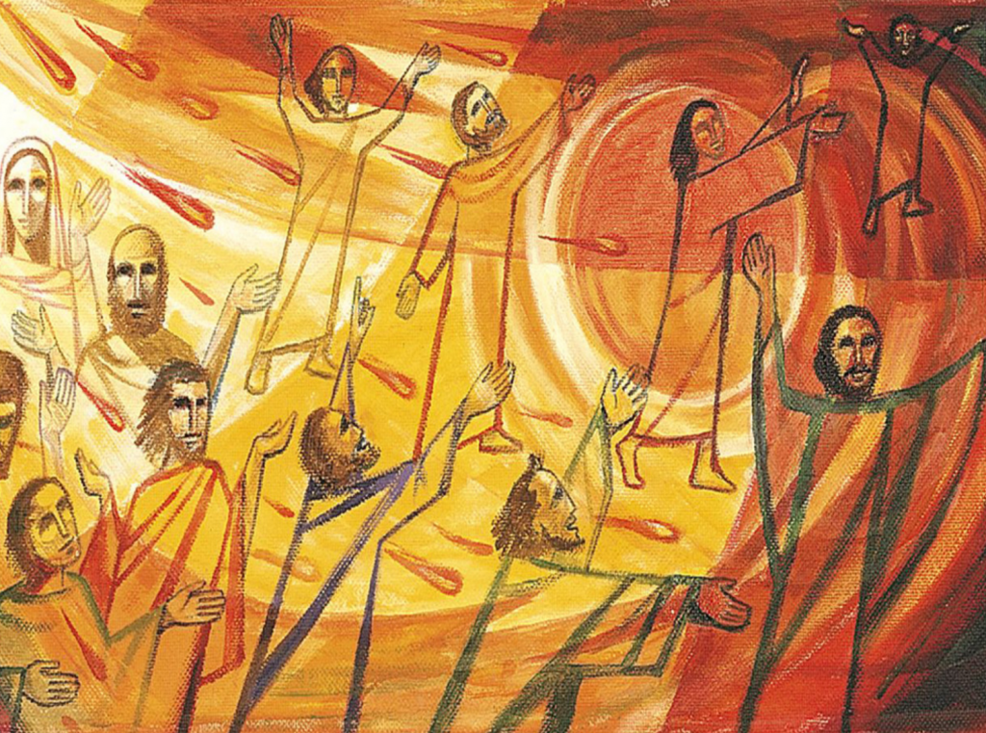
Pentecost – Whit Sunday
Sunday 23rd May 2021
10.00am
Welcome, Introduction, and Prayer of Preparation
Grace, mercy and peace from God our Father
and the Lord Jesus Christ be with you
And also with you.

Hymn 1. Holy Spirit, living breath of God sung by St Martin’s Voices
1 Holy Spirit, living Breath of God,
breathe new life into my willing soul.
Bring the presence of the risen Lord
to renew my heart and make me whole.
Cause your word to come alive in me;
give me faith for what I cannot see;
give me passion for your purity;
Holy Spirit, breathe new life in me.

2 Holy Spirit, come abide within,
may your joy be seen in all I do.
Love enough to cover every sin
in each thought and deed and attitude:
kindness to the greatest and the least,
gentleness that sows the path of peace.
Turn my strivings into works of grace;
Breath of God, show Christ in all I do.
3 Holy Spirit, from creation's birth,
giving life to all that God has made,
show your power once again on earth,
cause your church to hunger for your ways.
May the fragrance of our prayers arise;
lead us on the road of sacrifice,
that in unity the face of Christ
may be clear for all the world to see.
Keith Getty (born 1974) and Stuart Townend (born 1963)
© 2005 Thankyou Music/Adm. by Kingswaysongs, a division of David C Cook, www.kingswayworship.co.uk Used by permission (CCLI 4779872)

Confession
Jesus says, ‘Repent, for the kingdom of heaven is close at hand.’
So let us turn away from sin and turn to the Lord,
confessing our sins in penitence and faith.

Almighty God, our heavenly Father,
we have sinned against you
and against our neighbour,
in thought and word and deed,
through negligence, through weakness,
through our own deliberate fault.
We are truly sorry,
and repent of all our sins.
For the sake of your Son Jesus Christ,
who died for us,
forgive us all that is past;
and grant that we may serve you
in newness of life
to the glory of your name.
Amen.

Absolution
Almighty God,
who forgives all who truly repent,
have mercy upon us,
pardon and deliver us from all our sins,
confirm and strengthen us in all goodness,
and keep us in life eternal;
through Jesus Christ our Lord.
Amen.

Psalm 104:24-33
²⁴ How many are your works, Lord!
In wisdom you made them all;
the earth is full of your creatures.
²⁵ There is the sea, vast and spacious,
teeming with creatures beyond number –
living things both large and small.
²⁶ There the ships go to and fro,
and Leviathan, which you formed to frolic there.
²⁷ All creatures look to you
to give them their food at the proper time.
²⁸ When you give it to them,
they gather it up;
when you open your hand,
they are satisfied with good things.
²⁹ When you hide your face,
they are terrified;
when you take away their breath,
they die and return to the dust.
³⁰ When you send your Spirit,
they are created,
and you renew the face of the ground.
³¹ May the glory of the Lord endure for ever;
may the Lord rejoice in his works –
³² he who looks at the earth, and it trembles,
who touches the mountains, and they smoke.
³³ I will sing to the Lord all my life;
I will sing praise to my God as long as I live.
³⁴ May my meditation be pleasing to him,
as I rejoice in the Lord.

Reading read by Eileen
Acts 2:1-21
When the day of Pentecost came, they were all together in one place. ² Suddenly a sound like the blowing of a violent wind came from heaven and filled the whole house where they were sitting. ³ They saw what seemed to be tongues of fire that separated and came to rest on each of them. ⁴ All of them were filled with the Holy Spirit and began to speak in other tongues as the Spirit enabled them.

⁵ Now there were staying in Jerusalem God-fearing Jews from every nation under heaven. ⁶ When they heard this sound, a crowd came together in bewilderment, because each one heard their own language being spoken. ⁷ Utterly amazed, they asked: ‘Aren’t all these who are speaking Galileans? ⁸ Then how is it that each of us hears them in our native language? ⁹ Parthians, Medes and Elamites; residents of Mesopotamia, Judea and Cappadocia, Pontus and Asia, ¹⁰ Phrygia and Pamphylia, Egypt and the parts of Libya near Cyrene; visitors from Rome ¹¹ (both Jews and converts to Judaism); Cretans and Arabs – we hear them declaring the wonders of God in our own tongues!’ ¹² Amazed and perplexed, they asked one another, ‘What does this mean?’
¹³ Some, however, made fun of them and said, ‘They have had too much wine.’

¹⁴ Then Peter stood up with the Eleven, raised his voice and addressed the crowd: ‘Fellow Jews and all of you who live in Jerusalem, let me explain this to you; listen carefully to what I say. ¹⁵ These people are not drunk, as you suppose. It’s only nine in the morning! ¹⁶ No, this is what was spoken by the prophet Joel:

¹⁷ ‘“In the last days, God says,
I will pour out my Spirit on all people.
Your sons and daughters will prophesy,
your young men will see visions,
your old men will dream dreams.
¹⁸ Even on my servants, both men and women,
I will pour out my Spirit in those days,
and they will prophesy.
¹⁹ I will show wonders in the heavens above
and signs on the earth below,
blood and fire and billows of smoke.
²⁰ The sun will be turned to darkness
and the moon to blood
before the coming of the great and glorious day of the Lord.
²¹ And everyone who calls
on the name of the Lord will be saved.”

John 15:26-27;16:4b-15
²⁶ ‘When the Advocate comes, whom I will send to you from the Father – the Spirit of truth who goes out from the Father – he will testify about me. ²⁷ And you also must testify, for you have been with me from the beginning.

16⁴I did not tell you this from the beginning because I was with you, ⁵ but now I am going to him who sent me. None of you asks me, “Where are you going?” ⁶ Rather, you are filled with grief because I have said these things. ⁷ But very truly I tell you, it is for your good that I am going away. Unless I go away, the Advocate will not come to you; but if I go, I will send him to you. ⁸ When he comes, he will prove the world to be in the wrong about sin and righteousness and judgment: ⁹ about sin, because people do not believe in me; ¹⁰ about righteousness, because I am going to the Father, where you can see me no longer; ¹¹ and about judgment, because the prince of this world now stands condemned.

¹² ‘I have much more to say to you, more than you can now bear. ¹³ But when he, the Spirit of truth, comes, he will guide you into all the truth. He will not speak on his own; he will speak only what he hears, and he will tell you what is yet to come. ¹⁴ He will glorify me because it is from me that he will receive what he will make known to you. ¹⁵ All that belongs to the Father is mine. That is why I said the Spirit will receive from me what he will make known to you.’

Sermon

Hymn 2 Come Holy Ghost our souls inspire
sung by the Choir of Keble College Oxford.

- Come, Holy Ghost, our souls inspire,
and lighten with celestial fire;
thou the anointing Spirit art,
who dost thy sevenfold gifts impart:
- Thy blessèd unction from above
is comfort, life, and fire of love;
enable with perpetual light
the dullness of our blinded sight:

- Anoint and cheer our soiled face
with the abundance of thy grace:
keep far our foes, give peace at home;
where thou art guide no ill can come.

- Teach us to know the Father, Son,
and thee, of both, to be but One;
that through the ages all along
this may be our endless song,

- Praise to thy eternal merit,
Father, Son, and Holy Spirit. Amen.

The Lord’s Prayer
Our Father in heaven,
hallowed be your name,
your kingdom come,
your will be done,
on earth as in heaven.
Give us today our daily bread.
Forgive us our sins
as we forgive those who sin against us.
Lead us not into temptation
but deliver us from evil.
For the kingdom, the power,
and the glory are yours
now and for ever.
Amen.
Collect for the Day of Pentecost
Holy Spirit, sent by the Father,
ignite in us your holy fire;
strengthen your children with the gift of faith,
revive your Church with the breath of love,
and renew the face of the earth,
through Jesus Christ our Lord.
Amen
Morning Collect
Almighty and everlasting God,
we thank you that you have brought us safely
to the beginning of this day.
Keep us from falling into sin
or running into danger,
order us in all our doings
and guide us to do always
what is righteous in your sight;
through Jesus Christ our Lord.
Amen.

Intercessions led by Jane

Hymn 3 Lord, thy church on earth is seeking sung by St Martin’s Voices
1 Lord, thy church on earth is seeking
thy renewal from above;
teach us all the art of speaking
with the accent of thy love.
We would heed thy great commission:
go now into every place-
preach, baptise, fulfil my mission,
serve with love and share my grace.
2 Freedom give to those in bondage,
lift the burdens caused by sin.
Give new hope, new strength and courage,
grant release from fears within:
light for darkness; joy for sorrow;
love for hatred; peace for strife.
These and countless blessings follow
as the Spirit gives new life.
3 In the streets of every city
where the bruised and lonely dwell,
let us show the Saviour's pity,
let us of his mercy tell;
to all lands and peoples bringing
all the richness of thy word,
till the world, thy praises singing,
hails thee Christ, Redeemer, Lord.
Hugh Sherlock (1905-1998)
© Successor to Hugh Sherlock/administered by The Trustees for Methodist Church Purposes (CCLI 7007449)
Notices and announcements
Closing Prayer

